**Practical 1 : DFS ( Sequential and Parallel Algorithms )**

#include <iostream>

#include <vector>

#include <stack>

#include <omp.h>

#include <cstdlib>

using namespace std;

const int MAX = 100000;

vector<int> graph[MAX];

bool visited[MAX];

void dfs(int node) {

stack<int> s;

s.push(node);

while (!s.empty()) {

int curr_node = s.top();

s.pop();

if (!visited[curr_node]) {

visited[curr_node] = true;

cout << curr_node << " ";

#pragma omp parallel for

for (int i = 0; i < graph[curr_node].size(); i++) {

int adj_node = graph[curr_node][i];

if (!visited[adj_node]) {

s.push(adj_node);

}

}

}

}

}

int main() {

cout << "This is Atharva Pingale's code";

cout << "\nPractical 1 : DFS ( Sequential and Parallel algorithms )";

int n, m, start_node;

double start_time, end_time;

cout << "\n\nEnter number of nodes : ";

cin >> n;

cout << "Enter number of edges : ";

cin >> m;

cout << "Enter the starting node of the graph : ";

cin >> start_node;

for (int i = 0; i < m; i++) {

int random_u = rand() % 999999;

int random_v = rand() % 999999;

graph[random_u].push_back(random_v);

graph[random_v].push_back(random_u);

}

// Sequential Algorithm

for (int i = 0; i < n; i++) {

visited[i] = false;

}

start_time = omp_get_wtime();

dfs(start_node);

end_time = omp_get_wtime();

double seq_time = end_time - start_time;

// Parallel Algorithm

for (int i = 0; i < n; i++) {

visited[i] = false;

}

start_time = omp_get_wtime();

dfs(start_node);

end_time = omp_get_wtime();

double parallel_time = end_time - start_time;

cout << "\n\nSequential Algorithm Time: " << seq_time << " seconds\n";

cout << "\nParallel Algorithm Time: " << parallel_time << " seconds\n";

return 0;

}

**Output :**

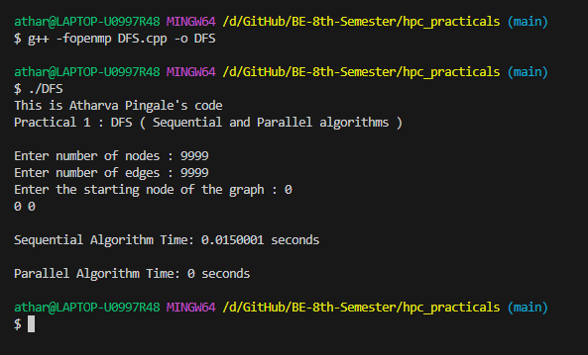

Sequential Algo Time : 0.0150001 seconds

Parallel Algo Time : 0 seconds

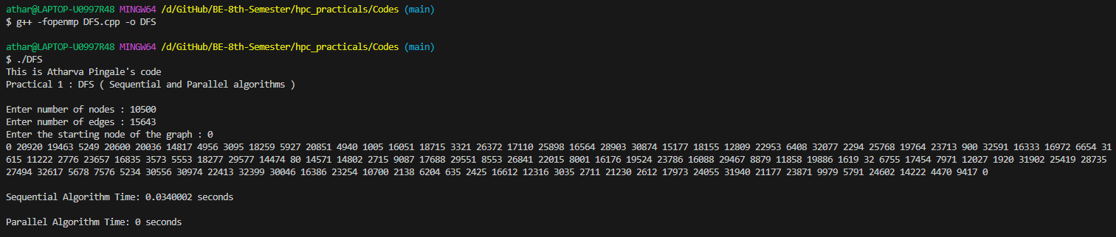

Sequential Algo Time : 0.0340002 seconds

Parallel Algo Time : 0 seconds

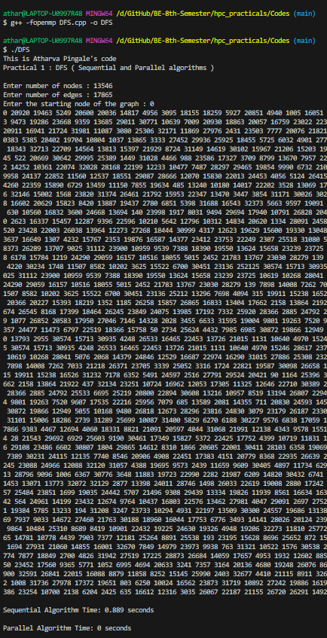

Number of Nodes : 13546

Number of Edges : 17865

Start node : 0

Sequential Algo Time : 0.889 seconds

Parallel Algo Time : 0 seconds